Renju lesson on February 8, 2001

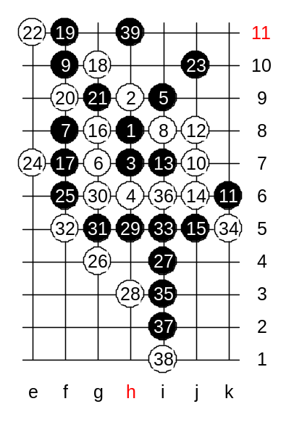
Hello all! Welcome to Online Renju Class. Lets continue with variants that we began to study last week. Last week we played 26-e8 and saw that black wins after that. In fact, it was the advanced level homework. That was the homework where many of you found the black win, but when I played it with Nakamura, I could not find the win. Today, we will try another 26th move. I am waiting for your proposals about correct 26th move. You have to see the whole position here: black has a winning activity on both lower and upper side. Primitive block on one side leads to inevitable loss on the other side. White should play actively in order to block and keep the tempo at the same time. Most of you suggest g4, that is quite good idea. In my home analysis before the match with Nakamura, I tested different continuations for black. Finally I decided that black must play actively to neutralize white material on the lower side. What choices does white have in move 30? Is e8 possible? Lets have yes/no voting. Do you agree that e8 is possible? Most of you say no. Why? Yes, black has VCF. Therefore, white must play g6 instead. The 32nd move – three choices. In order to make it very clear, lets begin with the weakest choices. F5. Since black plays a four to i5 anyway, so it makes the 32-f5 to be same as 32-k5.
By the 39th move black has neutralized white structures, and got another stone to upper side. That is the beginning of black’s powerful development in the upper side.
Can white defend in upper side? We do not know the answer for that. But we know that black is very powerful there and the winning chances are very high. Further moves are just a matter of game, and each of you may try his own style. We have proved the black advantage and is what we wanted. Lets go back and change to 32-i5 which is much better move.

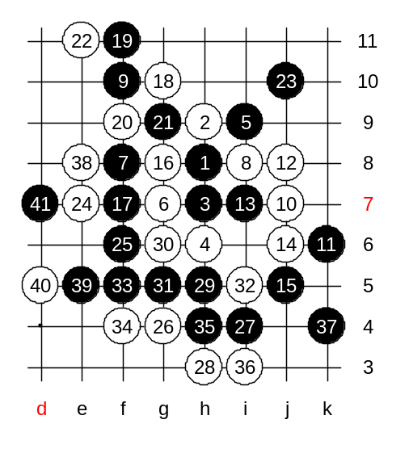
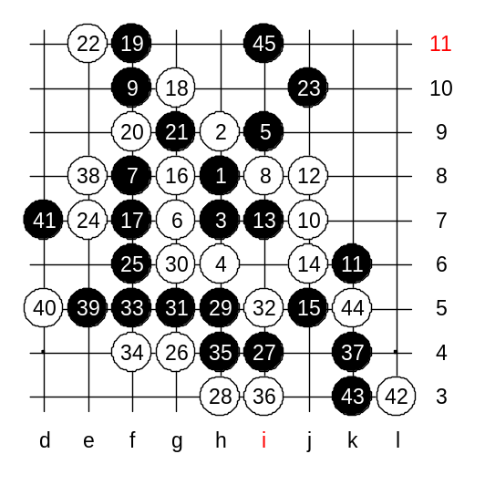
Now, we are back at 32-i5. According to my analysis, I used f5 and h4 to neutralize white structures and keep the black advantage in both lower and upper side. Now black has two potential attacking points – k4 and i11. You wonder that h4 is inside. Let me explain. In move 35 black has no VCT attack, at the same time white has some active structures on the left side. Black should block white structures. If black simply blocks from the left side, then black’s lower side is not so powerful anymore and white can simple block everything in upper side in next move. Move h4, although inside, blocks the white active material, and keeps the black’s lower side power alive. Black has to keep in mind, as long as he has two winning areas, it is not important whose turn it is and who has the tempo. You understand? If white plays passively 36-k4, then black wins in the upper side. If white plays passively to i11 then black wins in the lower side. White has to block the lower side first, and block it so that black has no time to go to upper side. Move 36-i3 is the key move of my analysis. What should black do next? OK, we try k4. Black plays it in clear reason – it is a fight for the tempo on the lower side, because the winner of the tempo has the chance to go to upper side first. If it is black, black wins, if it is white, then the game is quite balanced. Black plays aggressively k4 in order to keep the lower side attack alive. White should try to attack now, or else black takes advantage of its two winning areas. Lets try e8. Black moves e5 and d7 are forced. Indeed, white still has to block on the lower side. But the current situation gave white chance to play e8 and force black to play d7. As you remember, in case of 26-d8 (as Nakamura played), black could block the three from upper side and win. So, now was the good timing to play e8, and after that white has a helpful four at h11 or i12 for defense as well as defensive e-line structure. So, although white will block now on the lower side and lose tempo, white may have some chances for survive in upper side. How shall we block the lower side now? Yes, L3 is fine. By the 35th move, black has got the tempo and can go to attack in the upper side. Despite the white defensive material, black’s attack is strong and promising. So, white is having quite similar problems as on previous variant (32-f5).

Now I will introduce you the best ideas that white can use to defend in this variant. You will see the move that most of you probably could not guess.
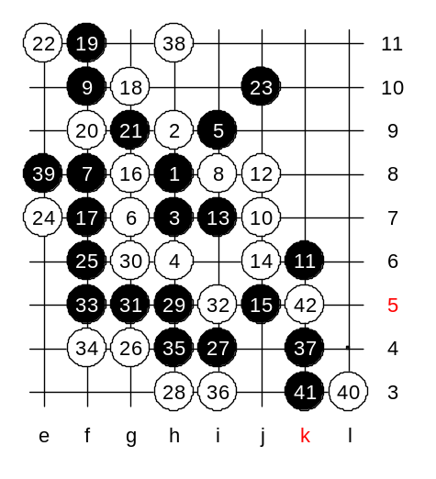
Let me explain you the idea first. We tried an active move e8 on previous diagram. The idea of the move was to play e5 in the next move. But black used the timing, the fact that four is faster than a three, and black played e5 first and then blocked white’s three. Note that the black’s four created a white stone to d5, but it is useless for white because white had already played to e8 and lost all possible connections with d5 point. So, how can white take advantage of its d5 stone? White can use the power of d5 stone to extend the white defense on upper side. Sounds strange, but it is true. The key of the d5 power is at h11 point. H11 is the answer. H11 is the move that makes d5 alive. Now, after h11, even if black plays e5 (it is forced, otherwise white self plays e5), it creates white stone at d5, and white connects there at d7!!, and therefore black must block on the left side now! Earlier when we played e8 first, then we lose the connection at d7. Now, d5 point supports h11 through d7 connection. So, black MUST play 39-e8 now. If you compare these two diagrams, on the previous diagram white and black were at e8 and d7, and now they are at h11 and e8. Now, having gotten one defensive stone at h11, white can defend on the lower side. By the 42nd move white has blocked both lower and upper side. And although black still has an advantage, it is not so dangerous anymore. Do you understand it?
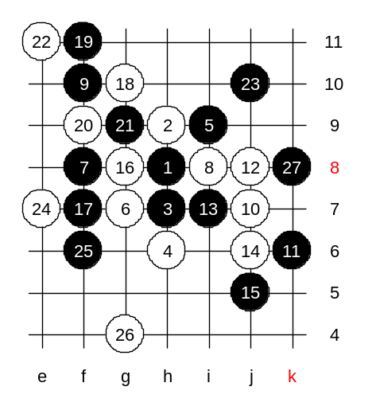

This is the advanced level homework. Please find the white win.

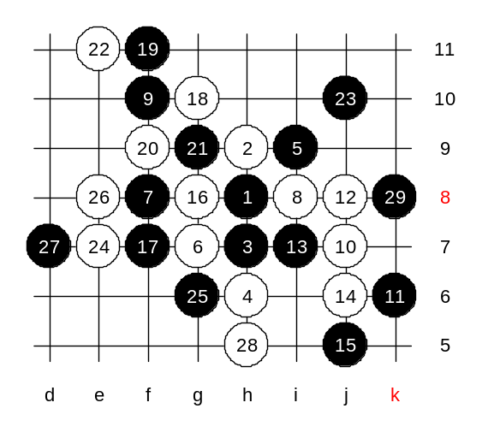

This is the medium level homework. Please find the white win.

